Practical - 6
Practical Title: Rendering External JSON Data using Fetch API, Search and Filter
Problem Definition: Display event lists, student profiles, notices, or FAQs from external JSON files using Fetch API. Implement dynamic rendering, search, filter, sorting, and pagination.

Theory :
1. How is JSON fetched, parsed, and rendered?

JSON is fetched using the Fetch API, parsed using response.json(), and then rendered dynamically on the webpage using JavaScript DOM methods such as textContent or innerHTML.

2. Which array methods are used for search, filter, sort, and pagination?

filter() is used for search and filtering, sort() for sorting, and slice() for pagination.

3. How are loading and error states handled?

Loading is handled using the Fetch API, while errors are handled using the .catch() method and displayed in the browser console.

4. How is modularity maintained in JavaScript files?

Modularity is maintained by using an external JavaScript file and separating different functionalities into independent code sections or functions.

Data:

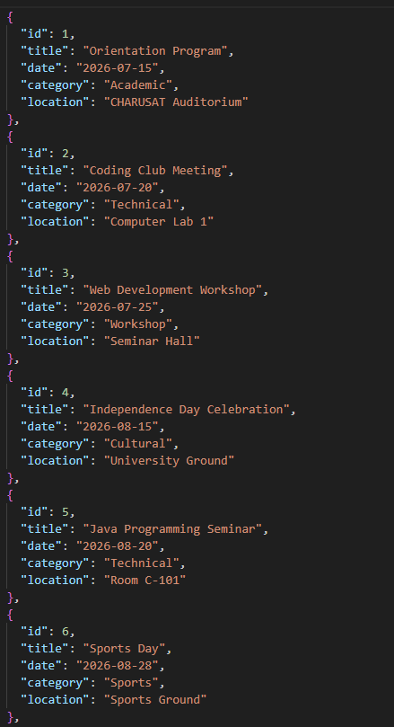

Implementation/ Output/Result

GitHub Repository Link:
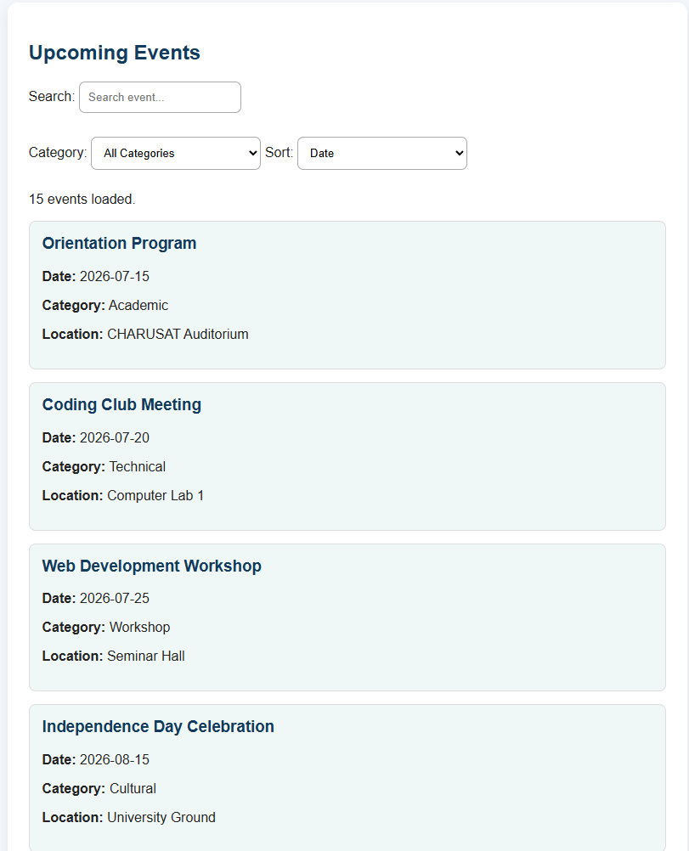
https://github.com/maniparayash5-hue/StudentHub.git

Learning Outcomes:

Understand how to fetch and parse external JSON data using the Fetch API.

Dynamically render JSON data on web pages using JavaScript.

Implement search, filtering, sorting, and pagination using JavaScript array methods.

Handle loading and error states while fetching data.

Develop modular and reusable JavaScript code for dynamic web applications.

Faculty Remarks: (Keep this blank for faculty)

